TITLE – WRITING OF AN ABSTRACT FOR THE NANOAFRICA2020 CONFERENCE
Authors - H. van der Walt¹, L.M. Sikhwivhilu¹ and J. Papo²
Affiliation ¹Nanotechnology, Mintek, Randburg, South Africa; ²Inorganic Chemistry, University of Johannesburg, Johannesburg, South Africa

The abstract should contain a concise description of the work to be presented. It will be edited and distributed to conference delegates as part of the programme. The required styles for the abstracts are contained herein.
All abstracts must be formatted in an A4 paper (210 x 297 mm). The top margin is to be set to 15 mm, the bottom to 25 mm and the left and right margins to 20 mm.
Please record references [1-2] as specified below in the reference section. Equations should use NanoAfrica2020 Equation style, centred and numbered as below:
P = [m/v] (1)
Please ensure that the figures used are described within the text and that all text on the figures/schemes is legible. Please note that the figure caption is placed below the figure, while the table caption is placed above the table as shown below in Table 1.
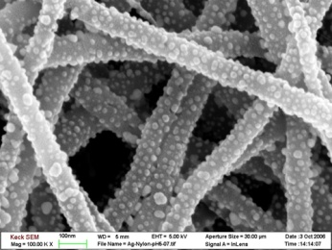
Figure 1 – Schematic illustrating the use of figures in the common text.
Table 1 – Illustrating the formatting of a table
Compound | Colour | Value
Fe₃O₄ | Brown | 2.53 ± 0.23 nm
Fe₃O₄@Au | Red | 5.21 ± 0.54 nm

REFERENCES
- L. Shen, P.E. Pan and R.E. Yes; Journal, year, volume, 2013 – 2015.
- L. Shen, P.E. Pan and R.E. Yes; Book title, 2013, Chapter 3, 2013 – 2015.

The authors would like to thank you for your submission.

Corresponding author Tel : +2711 999 9999
Corresponding author Email : info@nic.ac.za
Abstract guidelines

- The title should utilise the NanoAfrica2020 Title style and is recorded centred and in bold.
- Authors should be listed consecutively by initials and last name (as above) using the NanoAfrica2020 Authors style. Please underline the corresponding author and supply contact information at the end.
- Affiliations should be stipulated below the authors using the NanoAfrica2020 Affiliation style and indicated with superscripted Arabic numerical. Please do not append degrees, professional designations, etc., to names.
- Please record the text of the document in the NanoAfrica2020 Text style provided.
- Figures/Schemes should use the NanoAfrica2020 Figure style for figure captions.
- Scanned figures should have a minimum resolution of 300 dpi for a figure with an 80 mm width.
- Please use the NanoAfrica2020 Table style for tables.
- Please include the references for the abstract in the NanoAfrica2020 Reference style. Please number as illustrated.
- Abstracts should not exceed one page.
- Please submit the abstract as a Word 97/2000/XP/2003 etc. document for Windows or a Word 98/2001/X/2004 document for Mac.
- Please send the abstract, along with your preferred choice of presentation type (oral or poster) and conference session topic, to the NanoAfrica2020 secretariat at info@nic.ac.za.

